**Lab Exercise #1: Intro to ArcGIS Pro Due Tuesday, 09/10/2024**

## CRP 4080: Introduction to Geographic Information Systems

## Instructor: Wenzheng Li (wl563)

## Lab TAs:  Gauri Nagpal (gn247); Shubham Singh (ss3736); Anika Sinthy (ats243)

## Location: Sibley 305, Barclay Gibbs Jones Computer Lab

## Points Possible: 40

By the end of this lab, you should be familiar with the basic functions and organization of ArcGIS Pro.You should be able to create folders, add data, create a unique layer map and put together a map layout, as well as use some of the basic analysis tools in Arc Pro, and save your project.

At the beginning of each lab, you should copy the data from the course folder or Canvas site to your own folder at the beginning of each lab. Also, be sure to keep your course folder organized so that you will be able to find things in the future. Take the time now to set up a system that you can build upon in a logical manner.

Examine data structure in your Lab1_datafolder. There is only one shapefile for polling places for Tompkins County (we will be adding more later), but it is comprised of a number of files: a .shp file (shape file) and then several support files: .sbn, .sbx, .shx, .prj (this one defines the projection) and .dbf (the last one contains the attribute information).

1. **Creating a project**

You will notice that you have the option of opening a recent project or template. As we have not created a project, on the opening page, please click on the “Map” option under Blank Templates.

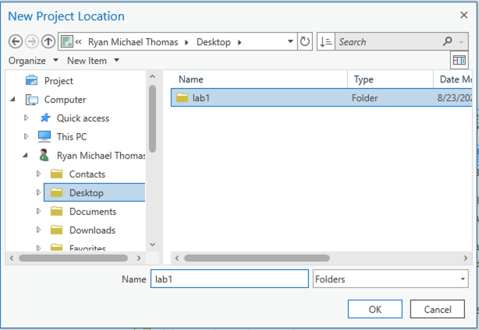

Figure 1. Select project folder

The “Create a new project” dialog box opens. Give your project a name (e.g., “lab_1”), and select the project folder you created with the lab 1 data (Figure 1). Uncheck the “Create a new folder for this project” box and click OK again to create the project (Figure 2).

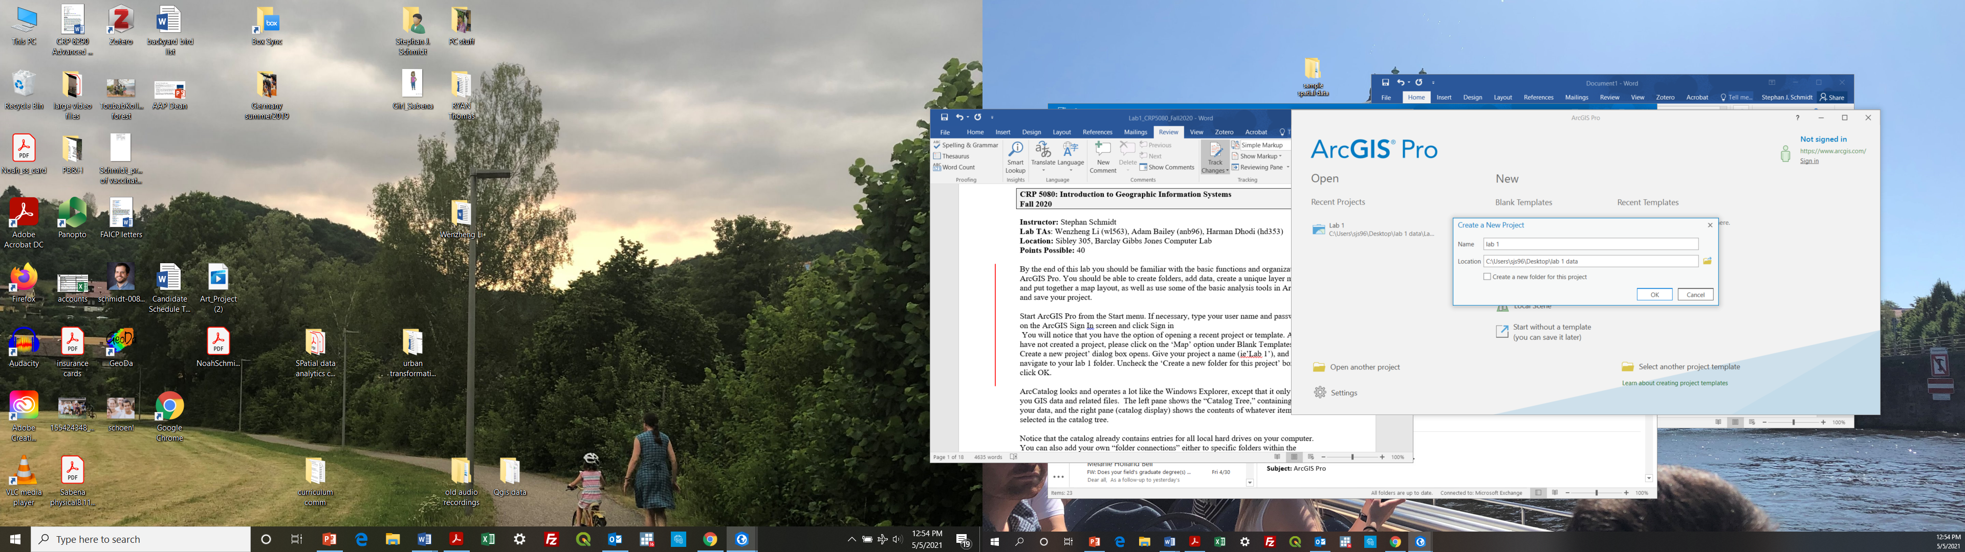

Figure 2. Create new project dialog.

## User Interface

The interface of ArcGIS Pro includes four major components: a **Ribbon**, a **Contents Pane**, a Map (View), and a Catalog Pane and Others (see Figure 3).

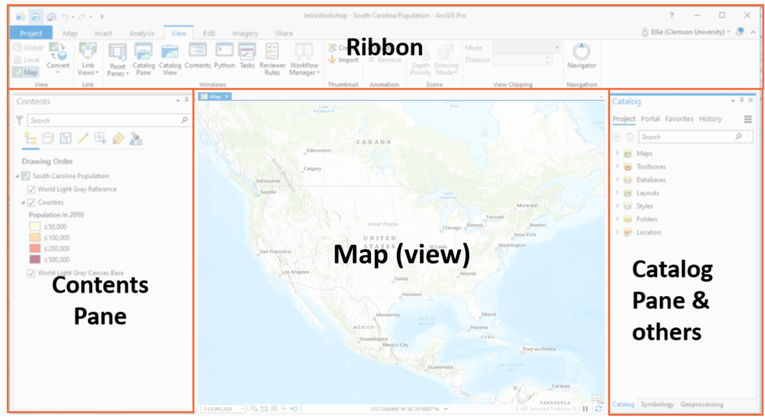

*Figure 3: Main GUI window.*

You will see a **Contents** pane (Figure 3, left side), a **Catalog** pane (Figure 3, right side). Panes are windows that help you manage views and projects, or that give you access to specific functionality.

The **Contents** pane lists items in the active view, such as layers in a map, or layout elements in a layout. The **Catalog** pane lists mostly data sources that belong to the project, such as databases, toolboxes, and folder connections. The **Catalog** pane also provides access to portal items, such as web layers.

## Open and dock panes

As you work, you'll often open and close panes that you need for specific tasks. The view above shows the Contents and Catalog panes in a docked state. You may also want to reposition panes or minimize them to make room for maps and other views. You can do this by dragging them around the window or dragging them off the window to make them a separate floating window (Figure 4).

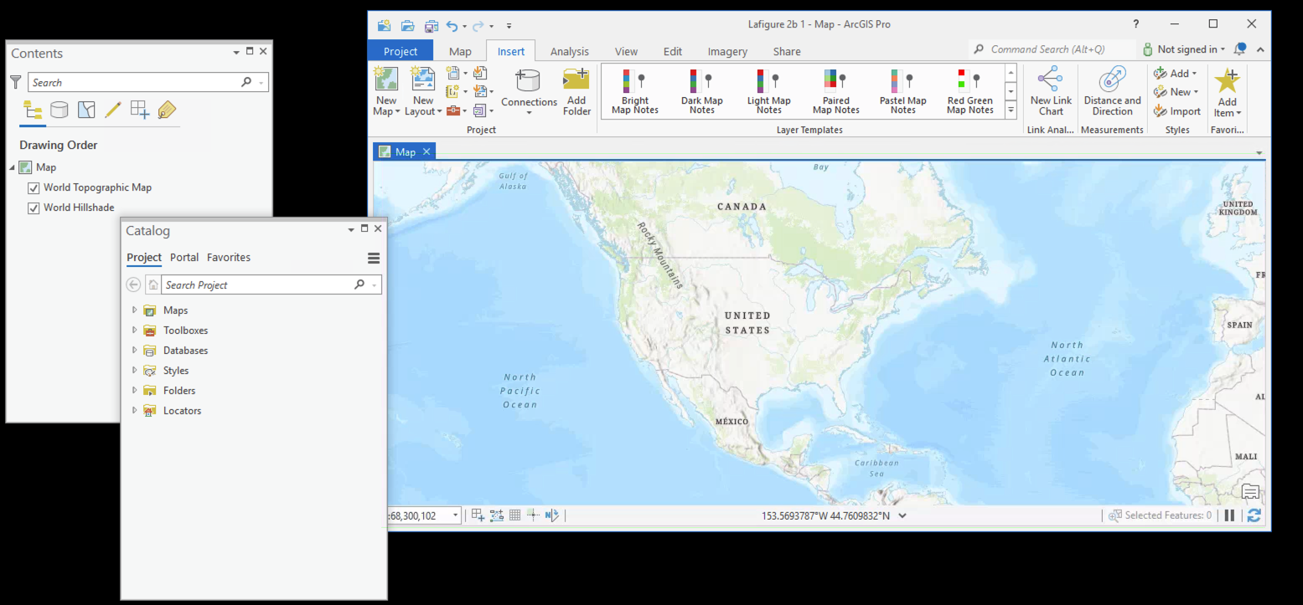*Figure 4. Main GUI window with Panes as separate windows.*

Pane states are independent of the project and will often appear in the arrangement of the previous ArcGIS Pro session. When you accidentally close them, you can go to View —> Windows and you can turn on them again.

## Ribbon

Above the map view is the **ribbon (**Figure 5**)**. The ribbon has a set of **tabs**—Map, Insert, Analysis, View, Edit, Imagery, and Share—that are always present when a map view is active. Each **tab** organizes a set of **tools** with similar or thematically grouped functions.

For example, the Map tab has tools for interacting with the map. On the Map tab, the Explore tool  is selected in the Navigate group. The Explore tool  allows you to move around the map and to read information about map features of interest.

On the ribbon, click the **View** tab. In the **Windows** group, click **Reset Panes**  and click **Reset Panes for Mapping (Default)**.

If the panes are stacked, they may also have tabs at the bottom that allow you to switch from one pane to the other.

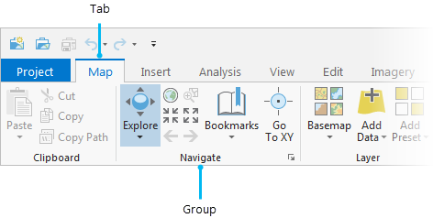

Figure 5. Ribbon with tabs and groups

As you drag the pane, docking targets—represented by a blue shadow—appear in the center of the map view and at the edges of the application window. Each target represents an area where the pane can be positioned.

Hover over a docking target. You can see where the pane will be docked if you drop it on that target.

The panes should now be docked on opposite sides of the ArcGIS Pro window. By default, panes stay open as you work. You can autohide a pane by clicking  so it doesn't take up space when you aren't using it. You can then toggle the panes to hide and reveal them.

Now that we have covered the very basic ways of interacting with the main GUI, experiment a little with the configuration to find a mode that works for you.

1. **Making a map**

Now we will begin to make a local map of Ithaca polling places using the data from ArcGIS online and the Lab 1 data folder. We will make a map with Parcels, …

First, we should zoom to Ithaca so we can see the data once we load it.

1. Under the Map tab, use the Locate tool to find Ithaca, NY. 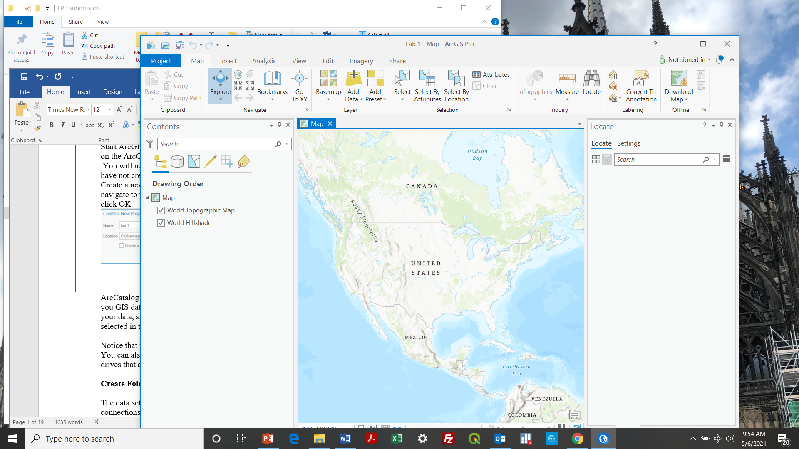
2. Adjust the base map
   1. Go to Map ribbon, under layer group, and click Basemap. 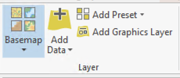
   2. You have a number of options. Select the one you prefer (In my case, the OpenStreetMap).

## Add a portal connection to ArcGIS online

There are two ways to add data in ArcGIS Pro: local data and online data. The new ArcGIS Pro is integrated with ArcGIS online, a cloud-based tool that users can upload datasets to. You can search and add data that is uploaded and maintained by other users in the ArcGIS cloud.

To add an ArcGIS online portal connection, complete the following steps:

1. 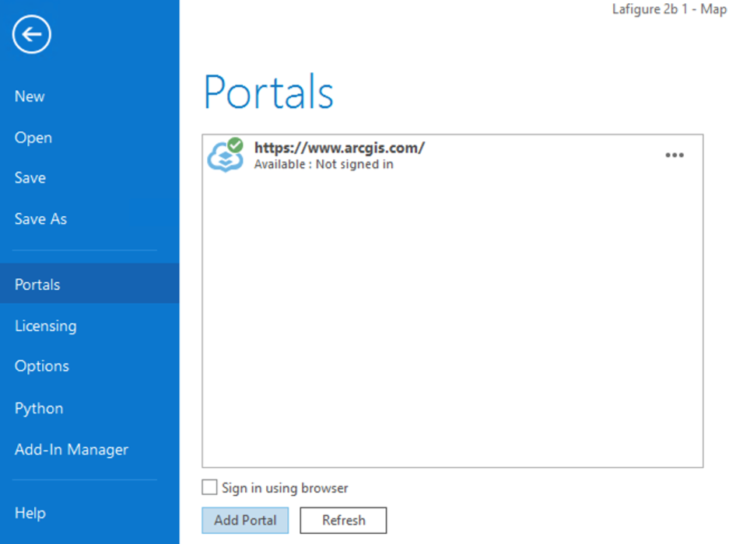Click the **Project** tab on the ribbon and Click the **Portals** page from the left side (see Figure 6).
2. Click **Add Portal**. Enter the URL for the portal on the **Add Portal** dialog box: <https://cugis.maps.arcgis.com> and Click **OK**.
3. Optionally sign-in to the portal. Click the **Options** button  or right-click the portal and Click **Sign in**. Enter your Cornell NetID as the username and NetID password. You can also [sign in to a portal using a web browser](https://pro.arcgis.com/en/pro-app/2.8/help/projects/sign-in-to-your-organization.htm#ESRI_SECTION1_1CAD4AEC94E54C1BA236F5CB2DC197D0).

Figure 6. Add portal

1. To make the new connection your active portal, Right-click the URL Click **Set As Active Portal**. To confirm this, you should see a green circle with a check mark next to this portal.

Click the back arrow in the top left corner to return to map view. Now we will add data to the map from the portal we just added. On the **Map** tab, click **Add Data** . Select ArcGIS Online (Figure 7).

We will now use the search bar at the top to search for datasets. Let’s search for data owned by TompkinsGIS:

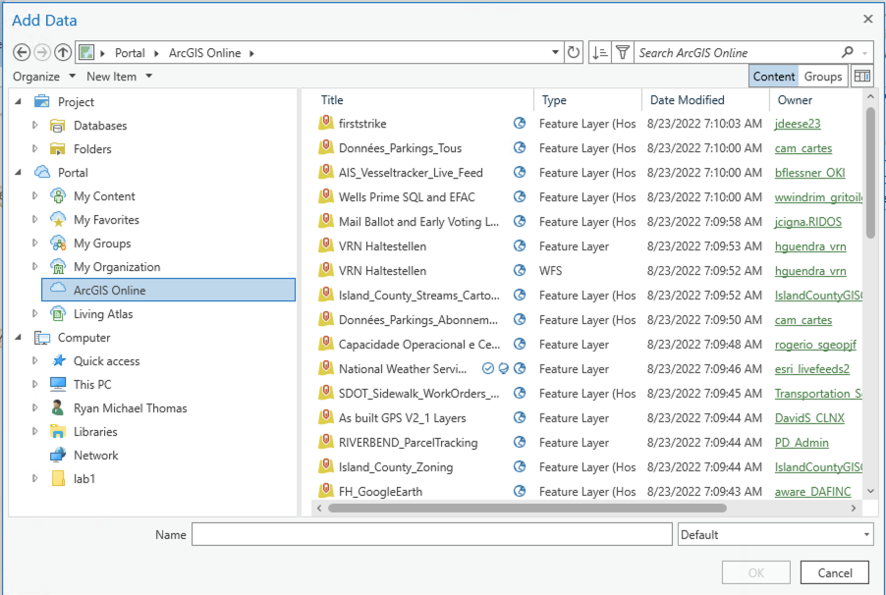

Figure 7. Add data dialogue

* Tompkins County parcels (search for “Parcels Tompkins”, then add Parcels_Public),
* building footprints (TCBuildings),
* streets (TcStreetEx) and
* municipal boundaries (TCMunis).

As you search, many options come up. Find the data sets that are owned by TompkinsGIS. For each layer, select the appropriate layer and Click OK to add it to the map. Make sure you can view the layers.

* Notice that some layers may not render properly when you are zoomed out (e.g., TCParcels). You can change this setting by right-clicking on the layer, selecting Properties, and under General, change Visible Scale Range to “show layer at all scales.” For some layers, like TCBuildings, you will want “show layer between certain scales” to speed up rendering when you are zoomed out.

Now, let’s add another layer from your **local drive**.

1. In the **Add Data** dialog, find your Lab 1 folder
2. select polling_places13.shp – polling locations. Note that only the file with the **.shp** extension shows up.

You can turn the various “layers” on and off, as well as rearrange the order in which they are presented by dragging them. **Rearrange the order from the top; polling_places13, TcStreetEx, TCBuildings, Parcels, and TCMunis**.

Note that there are shortcuts for commonly used functions. By right clicking on the layer in the Contents pane, you can directly access the attribute table and other options (e.g. remove layer, copy layer, etc.). “**Zoom to layer**” zooms to the full extent of the specific layer.

## Attribute table

Now we will examine the attribute table, which is tabular data about each feature in the shapefile. In the **Contents** pane, right click TCParcels layer and go to Attribute Table.

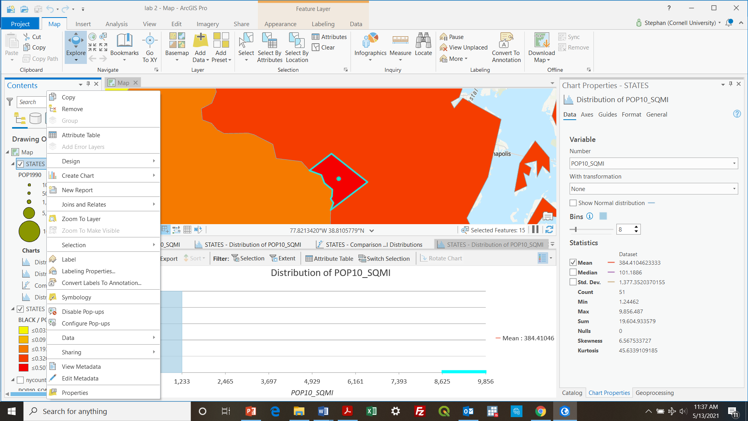

A window opens with the **parcels** layer attributes (Figure 8. Attribute table window), which will contain the attribute information about this layer.

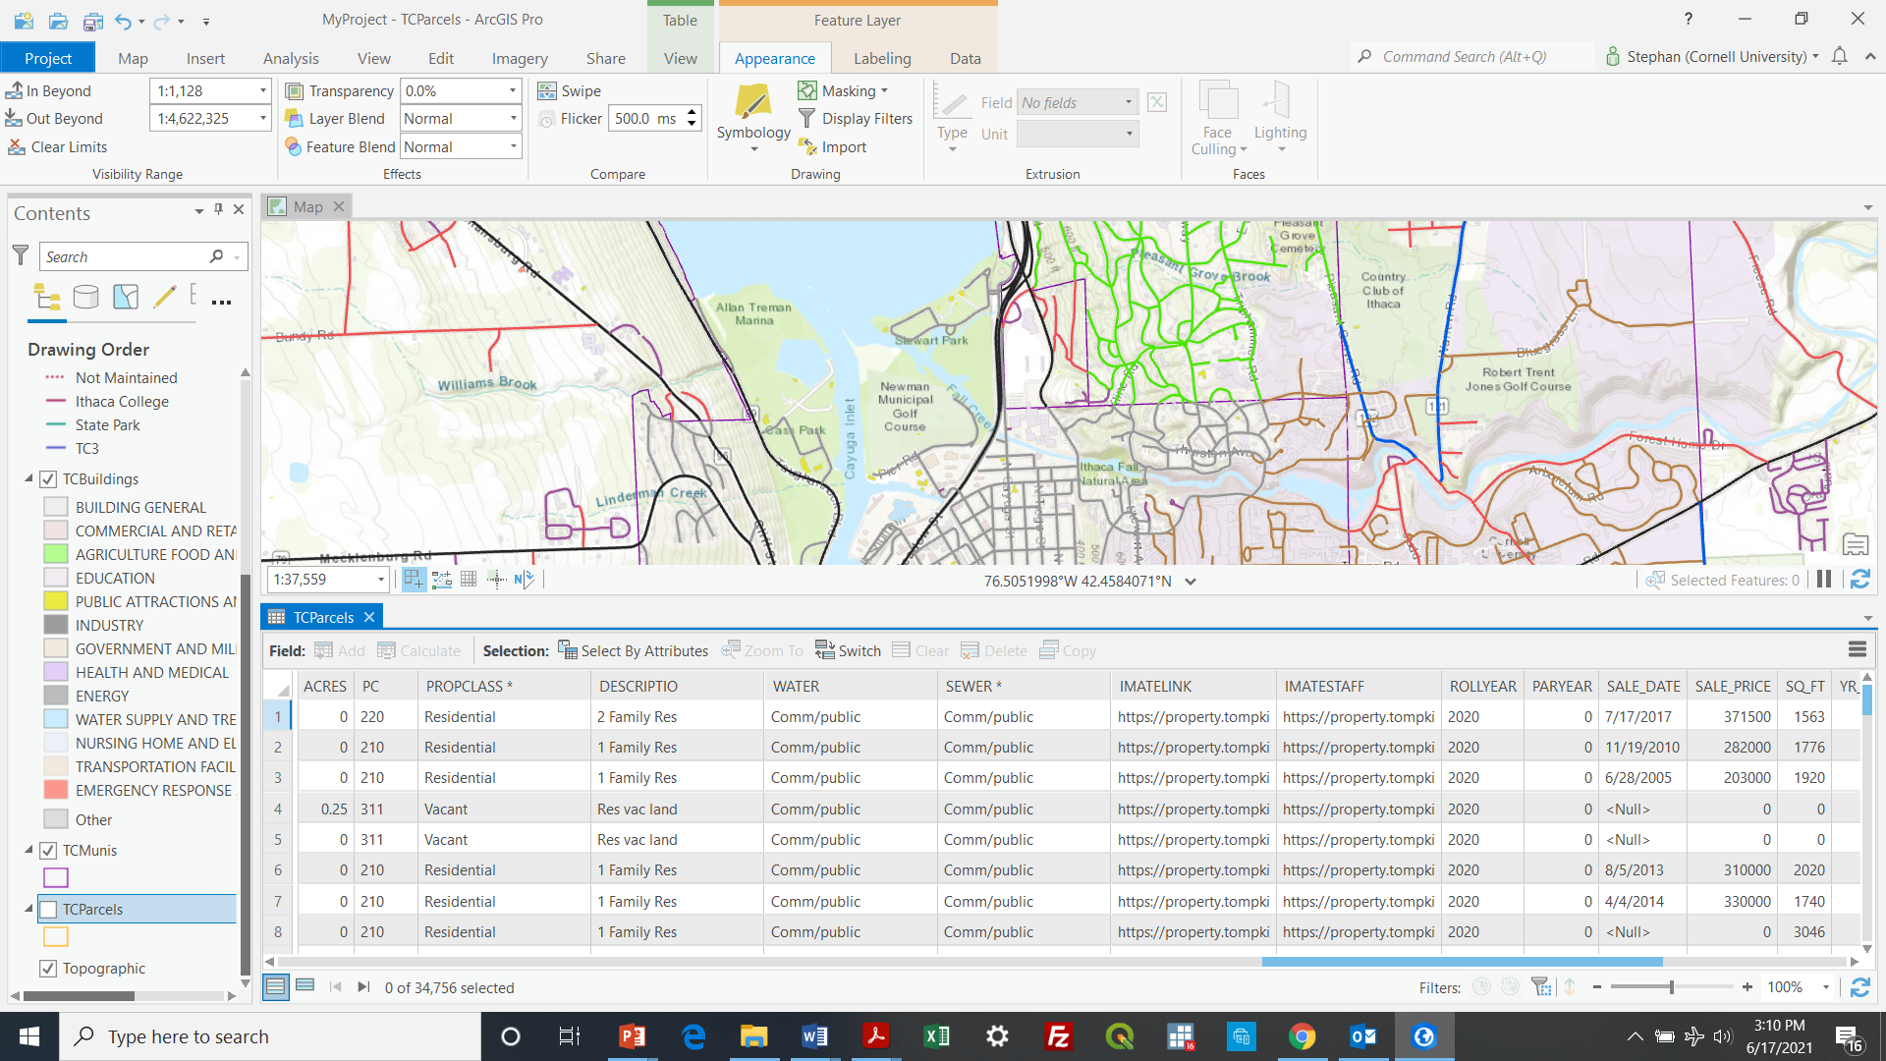*Figure 8. Attribute table window*

The attribute table is like a spread sheet in which rows represent features or shapes in the shapefile and columns represent attributes of those features. In this case, each row represents a parcel and each column corresponds to the attributes of the parcels. There is a one-to-one link between the features in the map and the rows in the table. This allows users to retrieve attribute information about any feature in the map. It also allows users to display one or more attributes for each geographic feature and create maps displaying attribute values.

The first column in the attribute table (**FID**) is a Feature ID, which is a unique number assigned to each feature, starting from zero. The **FID** is assigned automatically and cannot (and should not) be changed. The last column in the attribute table shows the type of feature (in this case polygon). The other columns all contain various attribute information. Some of these are recognizable, while others are probably not, and will require an examination of the metadata to determine what they represent.

Now let’s begin to assess the data. One keyway of doing this is through descriptive statistics, which summarize the distribution of attributes in our data.

1. Right click on the “Calcacres” column heading and
2. Go to ‘Statistics’. This will display a basic frequency distribution of parcel size.

Not particularly helpful. We can make a more detailed summary table.

1. Right click on TCParcels and Click to Create Chart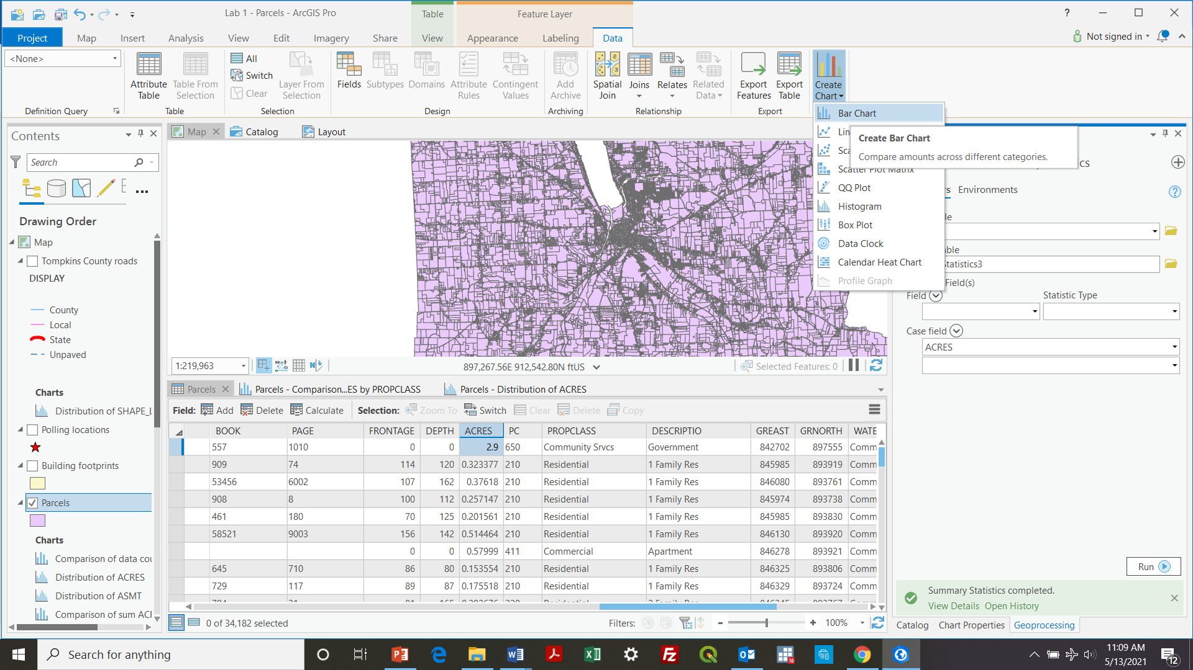.
2. Click Bar chart .

In Chart properties,

1. Select PROPCLASS as the category, SUM as the aggregation, and CALACRES as the Numeric field.
2. You may need to click “Apply”, or simply wait for the new chart to render.

This produces a more useful chart of acreage according to the property class. We could then export this chart as an image file using the Export button.

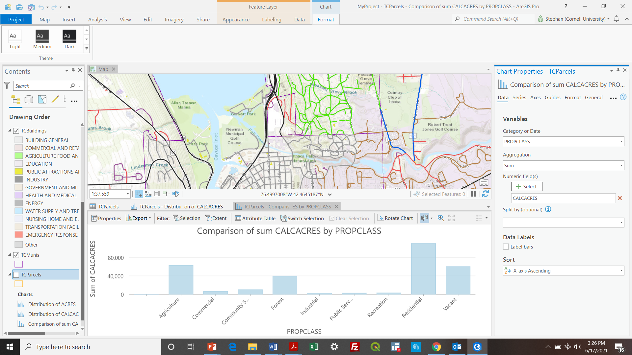

## Change the layer’s name

The current layer names and map names are not particularly legible. We can change layer names, so they are more legible and understandable (note: sometimes you may have to open the attribute table and look for clues to determine a more appropriate title).

1. First, give our Map a name.
   1. In the Contents pane, right click on the Map and
   2. Go to Map properties.
   3. Under the General tab, change the name to ‘Ithaca’. Click OK.
2. let us change the name of a layer.
   1. Right click on “TcStreetEx” layer and Select “Properties”.
   2. In the Layer Properties dialog box, select the “General” tab.
   3. Under “Name” type “Tompkins County Roads” and Click OK.
3. Change so the others read as follows:
   * TCBuildings: Building footprints
   * TCMunis: Municipal boundaries
   * polling_places13: Polling locations
   * TcStreets: Tompkins County roads
   * Tompkins County Parcels: Parcels

Note that you are not changing the name of the original layer files, only the name as it appears within the software.

# 3. Create a Map using the Municipal Boundaries layer

## Symbology

1. Turn off all layers except for Municipal boundaries.

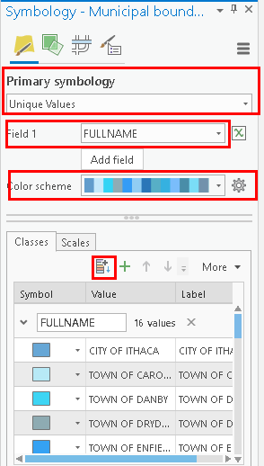

Figure 9. Symbology panel

1. Right click on Municipal boundaries layer and look at the attribute table. Note that while each municipality has a Name, these are often duplicate and contingent on the ‘MUNITYPE’ (City of Ithaca, Town of Ithaca, etc.). The attribute ‘FULLNAME’ will give us a unique name for each polygon.
2. Close the table, right click again and
3. Click on “Symbology” which will open the Symbology panel (Figure 9)

Since municipalities are *nominal* (also referred to as categorical) data, we want to create a ‘unique values’ map.

1. Under primary symbology, go to unique values.
2. For “Field 1,” choose FULLNAME, then
3. Click the ***add all values*** button 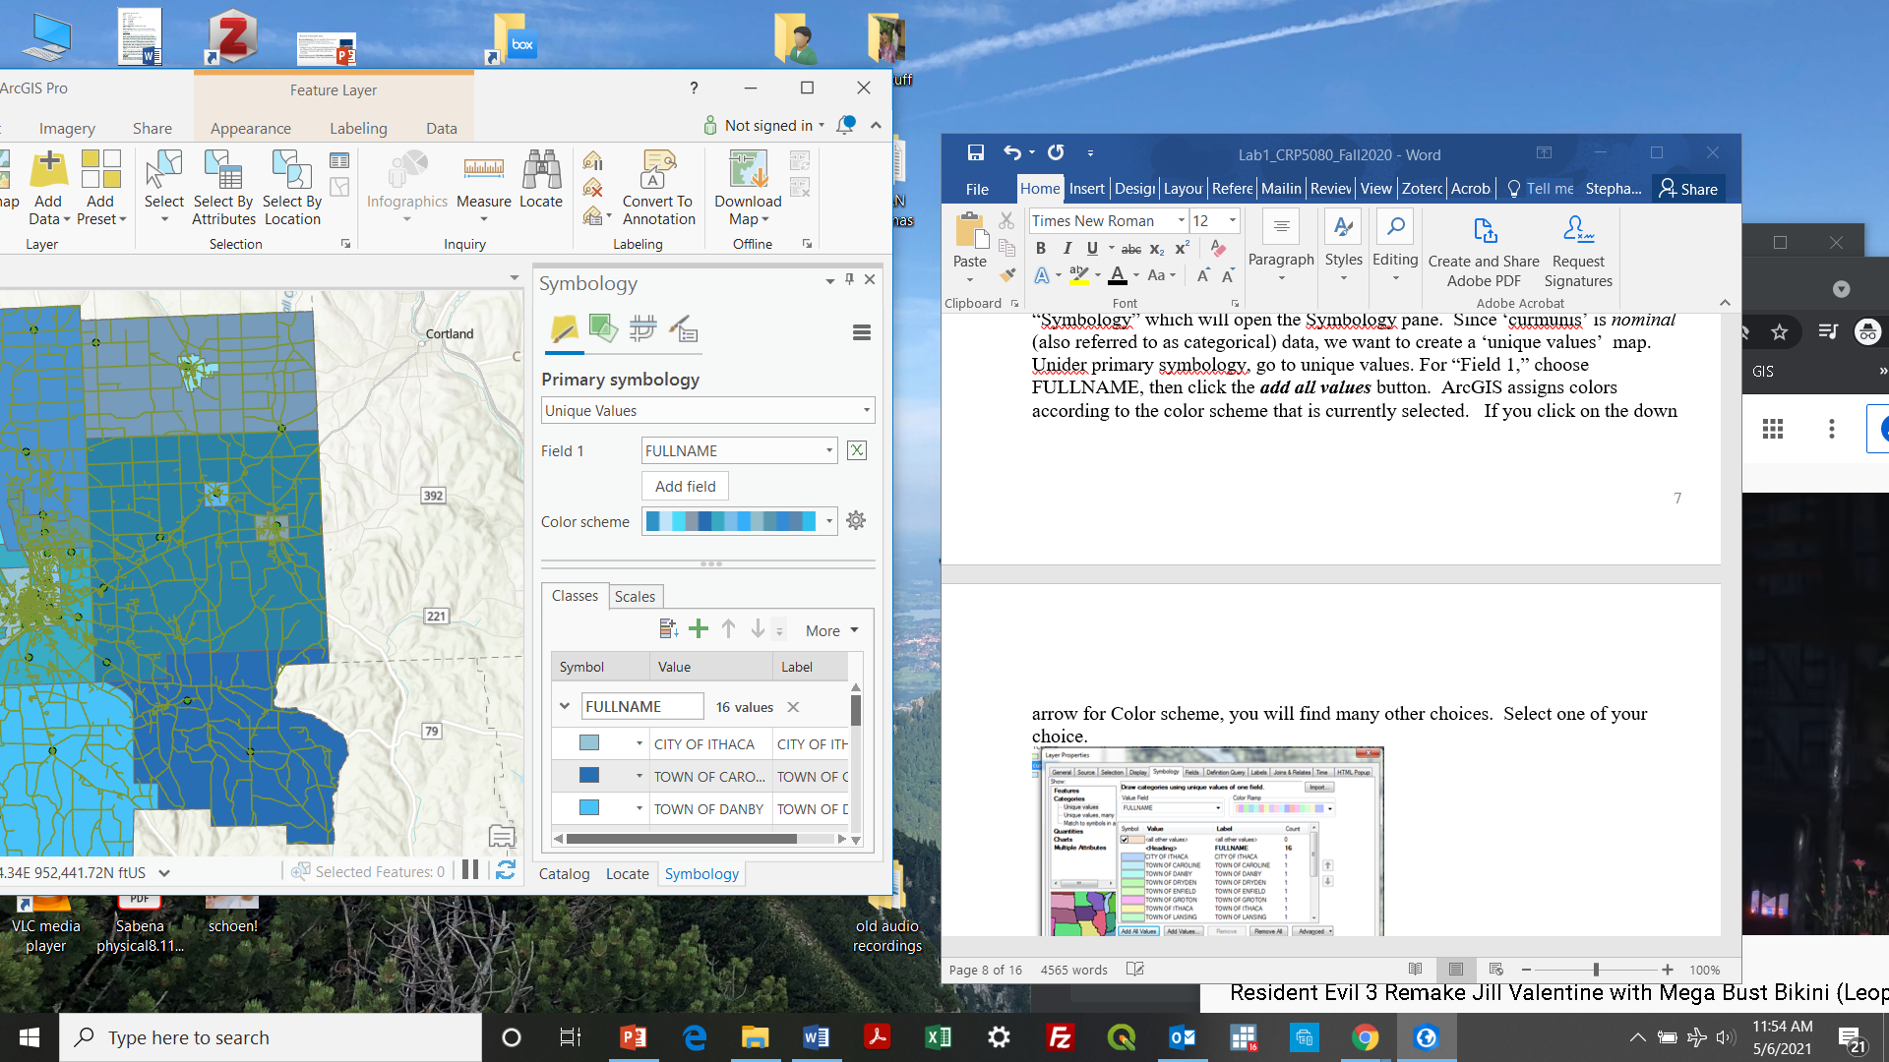 ArcGIS assigns colors according to the color scheme that is currently selected.

If you click on the down arrow for Color scheme, you will find many other choices. Select one of your choice. If you want to edit a particular feature, you double-click on it.

1. Double click on ‘City of Ithaca’ and change its color. Note that the symbol selector also includes pattern symbols in addition to solid colors.

Now to see the full extent of the layer, right click on the municipalities layer and go to ‘Zoom to layer’

## Creating Labels

1. Close the Symbology pane. Again, right click on the municipalities layer in the Contents and

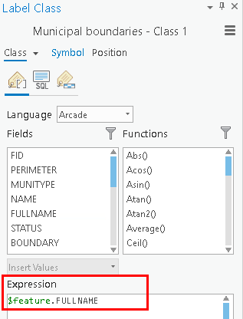

Figure 10. Label class dialog

1. Go to the Labeling properties.
2. Find the Expression box (Figure 10)
3. Notice the default attribute (‘$feature.NAME’).
4. Replace “NAME” with “FULLNAME”
5. Click Apply.
6. Return to the table of contents,
7. Right click on the municipalities layer, and go to ‘Label’ – the name of each municipality will now appear.

You have now created a *unique value map* for Tompkins County municipalities. You can also edit the placement, color, size, character case (upper or lower) and other attributes of labels.

Click [here](https://pro.arcgis.com/en/pro-app/latest/get-started/label-your-map.htm) for extensive tutorial on label formatting.

## Adjusting Symbology

Now we will explore other ways to adjust the layer symbologies, or how they are visualized on the map, which is a powerful design and analytical tool in GIS. Adjust the symbology of other features.

1. Right click on the Polling Locations, and
2. Select “Symbology.” This opens the Symbology dialog (Figure 11).
3. Change the points to stars (note that you can adjust the color and size as well)

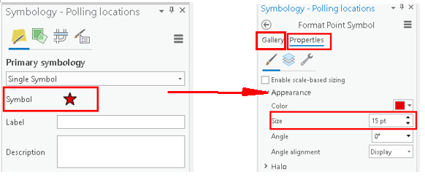

Figure . Symbology dialog for point layer

1. You will note that several of the layers from ArcGIS online were added with their symbology already classified. For example, streets are already classified according to the Maintenance variable, and Buildings are categorized according to type (BTYPE)
2. Right click on the Parcels layer and go to symbology. In the symbology dialog box, select ‘unique values’ as the primary symbology, ‘PROPCLASS’ as the field.

We now have created a *unique value* map of parcels categorized according to property type.

1. Please see [here](https://pro.arcgis.com/en/pro-app/latest/get-started/symbolize-your-data.htm) for an extensive tutorial on symbology in ArcGIS Pro.

## Save your Project

Save your project. Above the project tab, click Save: 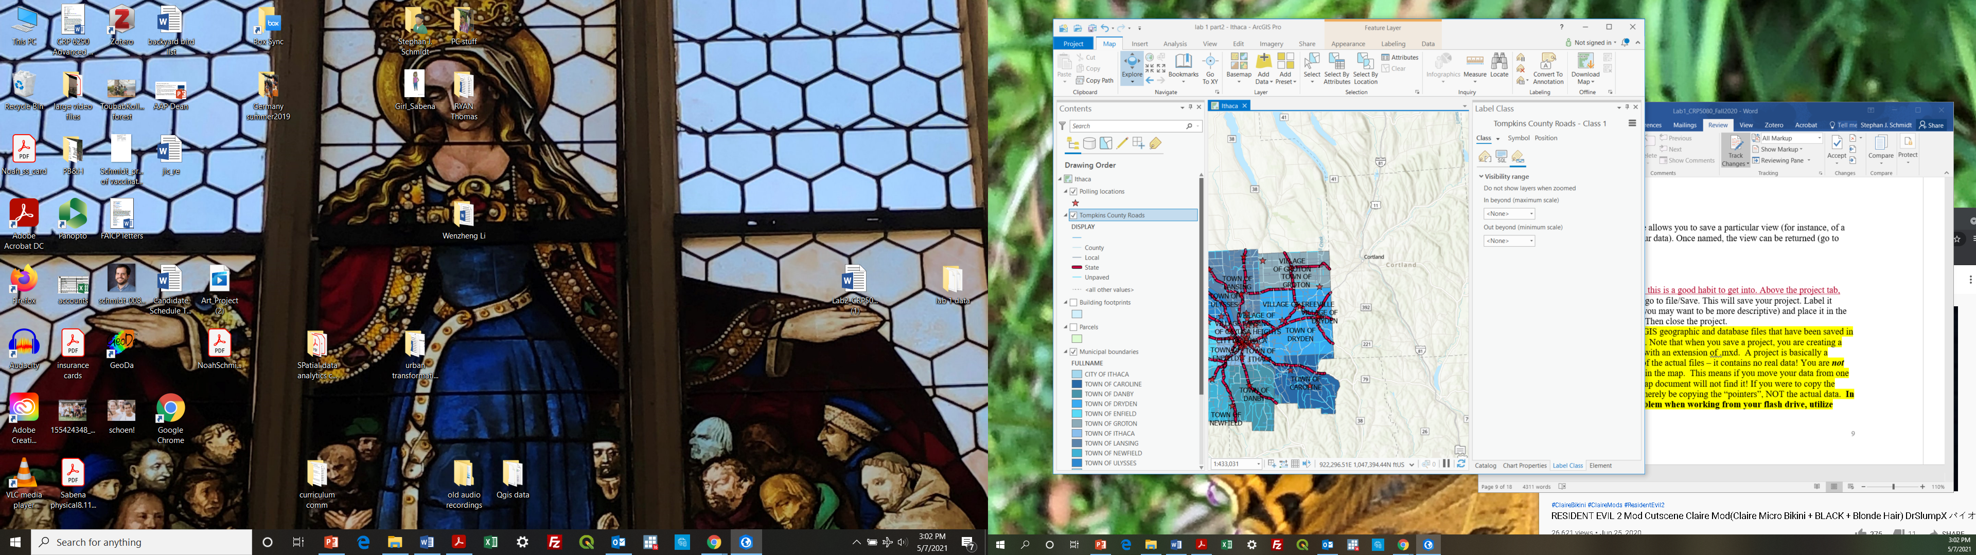. **Remember to save your project along the way!**

ArcGIS Pro uses *.aprx as its default project file type. A project is a set of ArcGIS geographic and database files that have been saved in a certain organized form. A project finds the data based on where they are located using file paths and URLs. You are ***not*** resaving and changing any of the data in the map. If you move the data or the project without moving the other one, your project document will not find the data!

From now on, you should create and save a project for each lab or homework assignment! First, copy all relevant data from the course folder to a (well labeled) folder you have created on your drive. Then create a new project. Save your project back into your folder with the data so you can return back to it, remember, the project is simply pointing to the data – if it can’t find the data you won’t be able to recreate the project.

Once you resume an ongoing ArcGIS Pro Project and find a red exclamation point  after certain layers. It means that you edit or change the data files (for example: changed the name of the data in folder or moved them to other directories) related to an existing project. The current project connection to the corresponding dataset is invalid. You have to rebuild the connection to restore the saved progress. See this detailed instruction on how to [**repair project items**](https://pro.arcgis.com/en/pro-app/2.8/help/projects/repair-project-items.htm).

**4. Creating a map layout**

Most lab assignments require you to submit maps. We can make maps using a map layout. For this layout, we will include a **zoomed view of downtown Ithaca** that displays **streets, parcels, and polling locations** with a **context map of Tompkins County** that has **all the municipal boundaries labeled with municipal names included**. Yes, each time you fail to include one of these elements you will lose points.

**Most importantly, these are the basic elements you should include to your map layout every time you create a map, or you will lose points on your homework.**

1. Title (and sub-titles if necessary)
2. Legend: Is it legible? Does it make sense? Are the titles coherent? Do the number breaks make sense?
3. Metadata/notes: Tell us about the map! Who created it? Where? Date? What is the data source? Projection? Units? How is the data classified? What is the purpose of the map?
4. Scale bar: Do units (feet, miles), breaks (not too many!) make sense?
5. A north arrow

## Creating a layout

1. Insert a blank layout.
   1. On the ribbon, click the **Insert** tab if necessary.
   2. In the **Project** group, click **New Layout**  to show page size and orientation options.
   3. Under **ANSI - Landscape**, click **Letter** (this is a matter of preference)

A new, blank layout view opens.

1. Name the layout.
   1. Activate the Layout tab.
   2. In the Contents pane, right-click the layout,
   3. Click **Properties**
   4. Click General,
   5. Change the name from **Layout** to ‘Ithaca’.

## Insert a map frame

Now let’s create a **Map Frame** in our layout.

1. Under the **Insert** tab, click the **Map Frame** drop-down arrow.
2. Select the frame with your data (not the default extent).
3. Use your mouse to draw a large rectangle on the layout and wait for it to load.

The map frame is added to the layout. It is currently selected, as indicated by selection handles. This will allow us to move it around the page to position it correctly.

1. Right click inside the frame and
2. Select ‘Activate’ (this can also be accessed through the Layout Tab at the top).

This will allow you to manipulate the layout data within the map frame and select the correct size and position for your data.

1. In the **Contents** pane, right-click **Map** and
2. Click **Properties**.
3. In the Map Frame **Properties** dialog box, click the **General** tab if necessary.
4. Change the name of the Map Frame to ‘Ithaca’. Notice at the top, we can toggle between the layout view and the map view.

This will be our main Map Frame, and the context map will have a different name.

In the Layout view, zoom in to the City of Ithaca area (remember you must have the map frame activated).

* The symbology of the polling places should be red stars.
* The symbology of the streets should be a single symbol.
* The symbology of the parcels should be categorized according to property class.

To **close an activation** session to avoid unintended changes, click the back to layout  Or just simply click the red-cross on the top-right of your layout frame.

## Add a second map frame (context map)

Now, let us create a context map. We need to create a new Map (not a Map Frame) before we can add this as a new Map Frame.

1. Under the **insert** tab, add a **New Map**. Note that insert a map, not a layout frame!!! In the **Contents pane**, Change the name to ‘Tompkins County’.
2. This time, add only the Municipal boundaries layer to this map frame. You can copy and paste from the Ithaca Map.

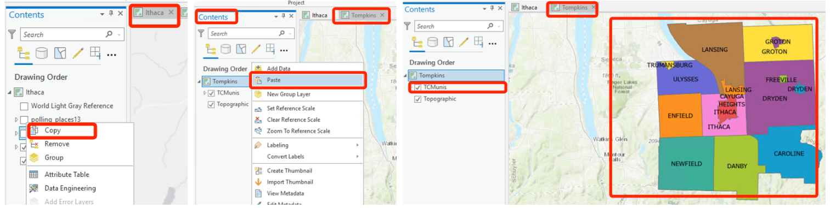

1. Rename the layer and create labels for their full names (feel free to experiment with placement and stylistic considerations).
2. Now add a second Map Frame to your **Ithaca layout** to display the Tompkins County map. This time when you select Map Frame drop down, you will see a second Map to select from, the Tompkins County Map.
3. Within the Table of contents, rename this Map frame ‘Tompkins County’.

Adding data frames is useful if you wish to include inset/overview maps, or to display maps of different variables in the same layout (e.g. for a poster presentation). Now, you can individually adjust each of the map frames on the page. To do that remember to **activate and de-activate** different map frames.

## Add map extent indicator

1. Let us include an extent indicator to indicate the relationship between the two map frames.
   1. 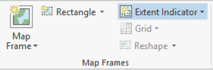Click the Map Frame of Tompkins County
   2. On the **Insert** tab, click the **Extent Indicator** drop-down arrow
2. Format the Extent Frame (Figure 13)
   1. Select the Ithaca map frame. (You must be clear what kind of relationship you want to indicate among these maps. In this case, the indicator is from Tompkins County to Ithaca!)
   2. Right-click the **Extent of Ithaca** layer in the Contents pane to open the **Format Extent Indicator** pane.
   3. In the **Format Extent Indicator** pane, under **Extent Indicator**, click the symbol, select an appropriate symbol for the extent map.
   4. Under Extent Indicator, check the **Apply Symbol outside extent tab**, and
   5. for Leader style select **Callout to Edges**.

This draws lines linking the source map frame and the extent indicator (Figure 13).

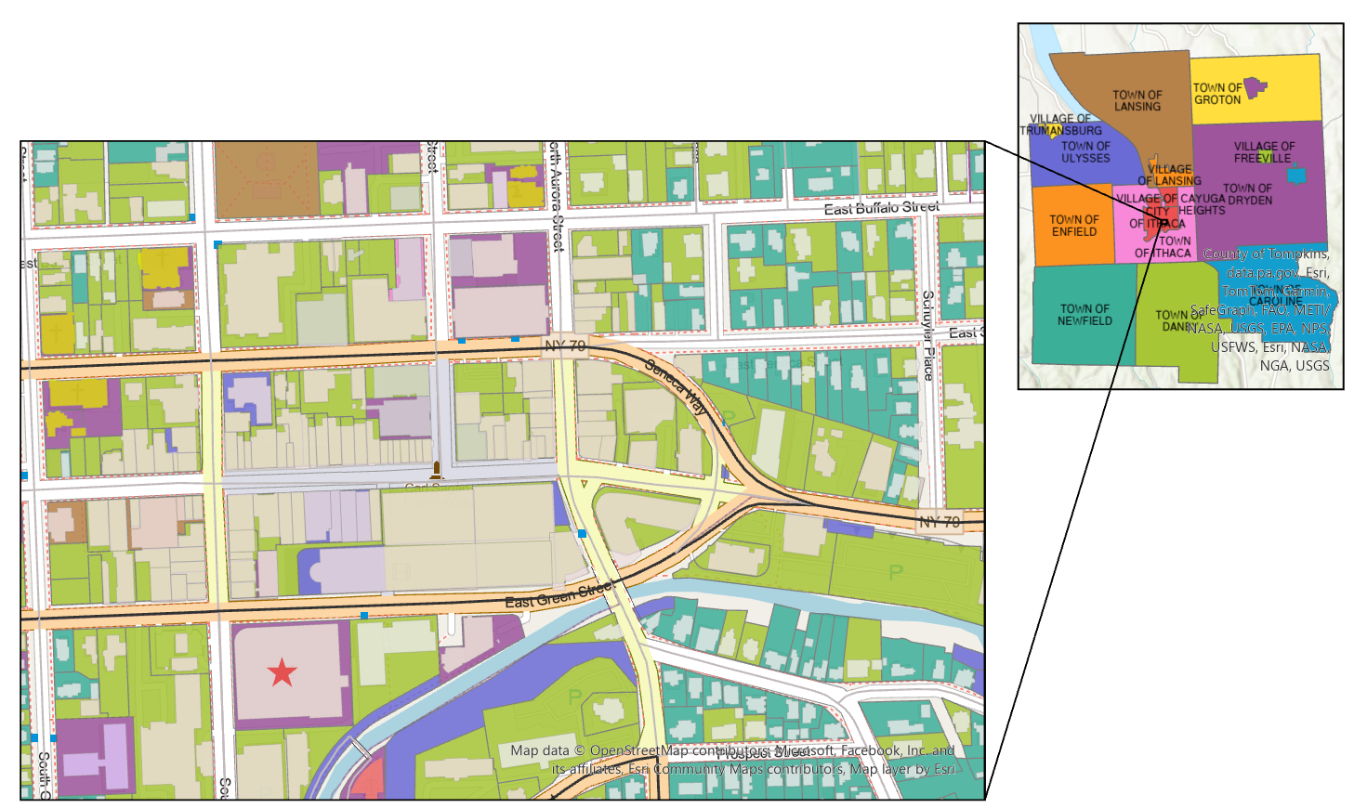

Figure 13. Context frame, detail frame, and callout lines contextualize this map nicely.

## Map layout elements

You'll add a legend, north arrow, and scale bar to the layout. The legend explains the map's symbology. The north arrow and scale bar provide geographic context.

**Insert Legends:**

Note: Before inserting a legend*,* spaces and any extraneous or unnecessary symbols or icons should be removed. You will also want to take this opportunity to delete unnecessary elements (for example, parcels contain a field for ‘All other values”, which is not particularly useful in a legend. Also, there are missing values in this layer, delete them for now. Open the Symbology for the parcels layer, and adjust (i.e., delete) both the Symbology and the text for this category (Just right-click and remove).

For this map, the legend should include the property classes, streets, and polling places.

*General notes on Legends:*

The legends below are for a map of household median income based on census data. Think about all the ways in which the legend on the left, which is what you get by accepting the ArcGIS defaults, is hard to understand. The bottom line: **DO not create a map with a legend that looks like the one on the left!**

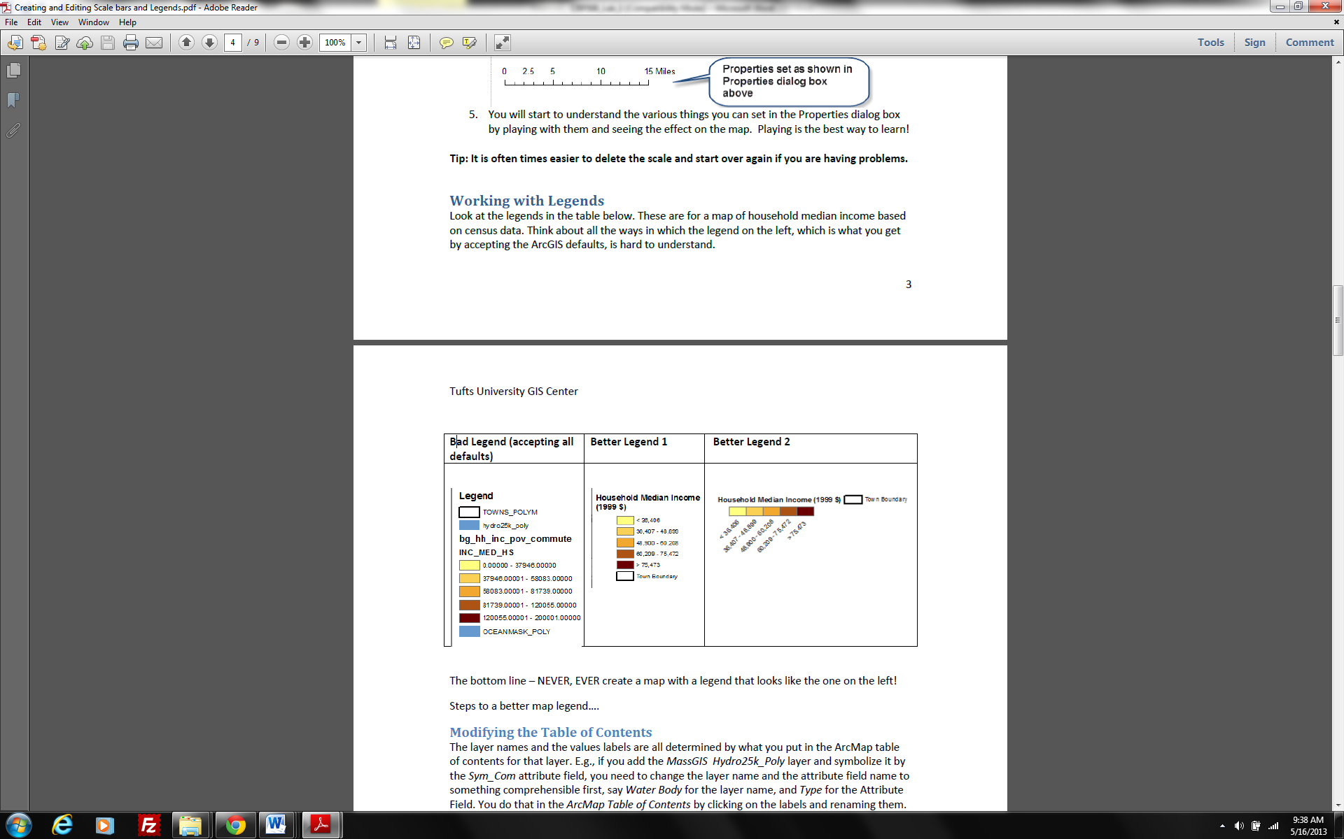

Now, let’s insert the legend. Under the Insert tab, click **Legend** .

On the layout, anywhere suitable on the map frame, draw a rectangle using your mouse for your legend. To work with the properties of the legend as a whole, right-click the **Legend** heading in the **Contents** pane and click **Properties** (Alternatively, right-click the selected legend on the layout). We are interested in displaying a legend for the ‘Ithaca’ map frame (not Tompkins County).

Note you can select which **Map frame’s** legend to show here. Try cleaning up the legend so that only the most important information is shown. Click the**Show Properties** and have a look at all those options under **Show**, normally, you don’t need show both layer name and headings.

Also, under **Feature Display Options**, select ***Only show features visible in the map extent***. This will help your legend look efficient!

Note: If you fail to clean the legend, you can convert the legend to a graphic and manipulate the legend independently. ***You should only use this function if the tools in legend properties window are not sufficient. Once you convert your legend to a graphic it is no longer connected to the data, which means the legend will no longer reflect changes you make on your map, e.g., it will not add new layers or reflect changes in colors.***

*The steps are as follows:*

*1. Right Click* on the legend and choose **Convert to Graphics.**

*2. Right Click* on the legend and choose **Ungroup.** You now can move and edit all of the elements of the legend independently.

3. When you are done with your edits, click the mouse and drag a rectangle over all of the elements of your legend to highlight all of them. Right click and choose **Group.**

***Insert Scale Bars:***

*A word on scale bars:*



* The first scale bar above is what ArcGIS gave as the default after we inserted a scale and did nothing else. It shows quite arbitrary numbers, e.g., 2,350 and 4,700, which are not acceptable.
* The second scale bar reflects the fact that we specified that the distance units be in miles, because for distances over a mile, it is easier to understand miles than feet (same with meters and kilometers). But again, the numbers are quite arbitrary.
* The last scale bar is in miles, and it is easy to read and to use as a measure on the map because it uses **whole numbers** **and has easily understandable divisions (0.25, 0.5, 0.75).** This was done easily by simply stretching out the scale bar manually until it said 2 miles (alternatively we could have compressed it to 1 mile)

The bottom line is – **NEVER** simply accept the default if it is not easy to read and to use! Take control over your scale bar!

*Now insert a scale bar: There are many options. Feel free to find one that works for you.*

*Place the scale bar, notice that the default may not be the most intuitive!*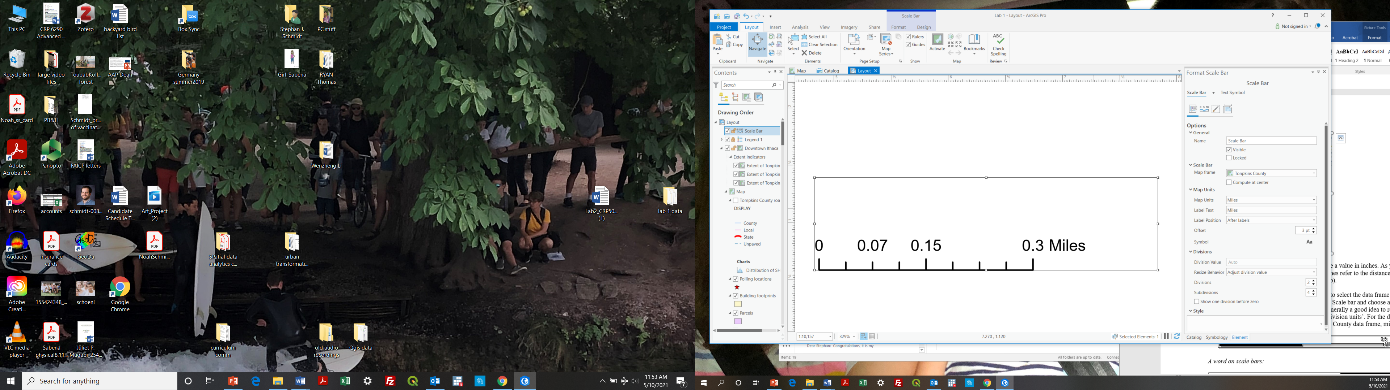

We can grab the end and extend the scale bar so that it includes more obvious break points.

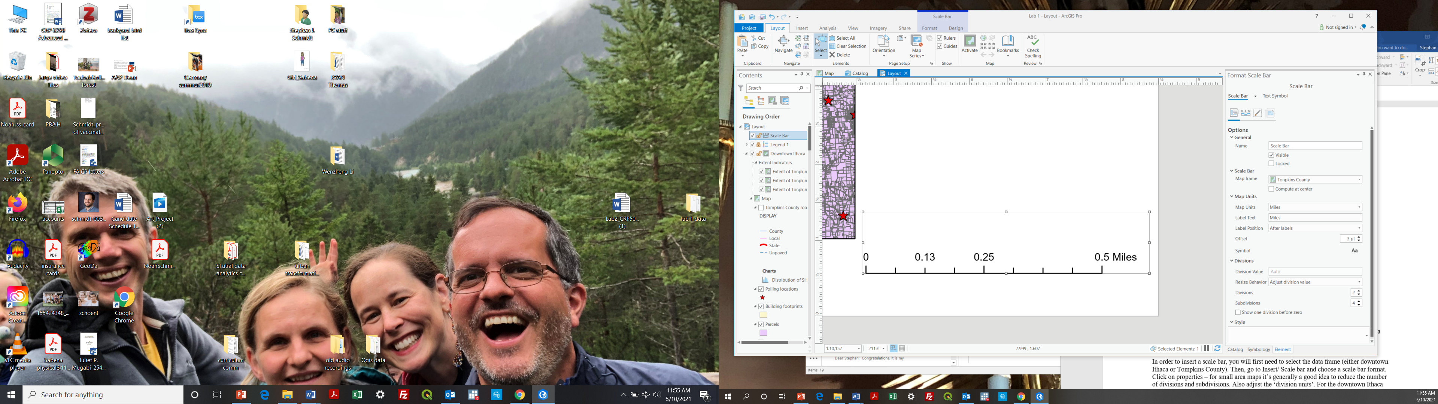

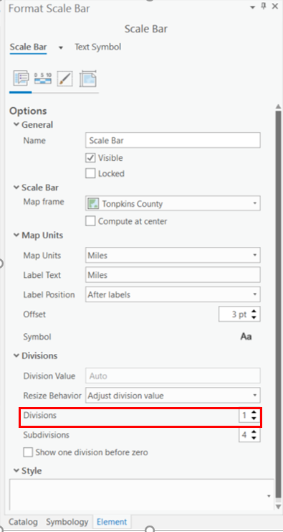Still a bit cluttered for my taste (0.13 miles is not an intuitive distance!) In the format scale bar pane, **reduce the number of divisions from 2 to 1**. Also note that we can adjust the map units as well as the map frame (Tompkins County is merely the context, so no need to create a scale bar). The downtown Ithaca map frame is important one here.

For the downtown Ithaca map, feet may be appropriate. For the Tompkins County data frame, miles may be appropriate.

Much better in my opinion!

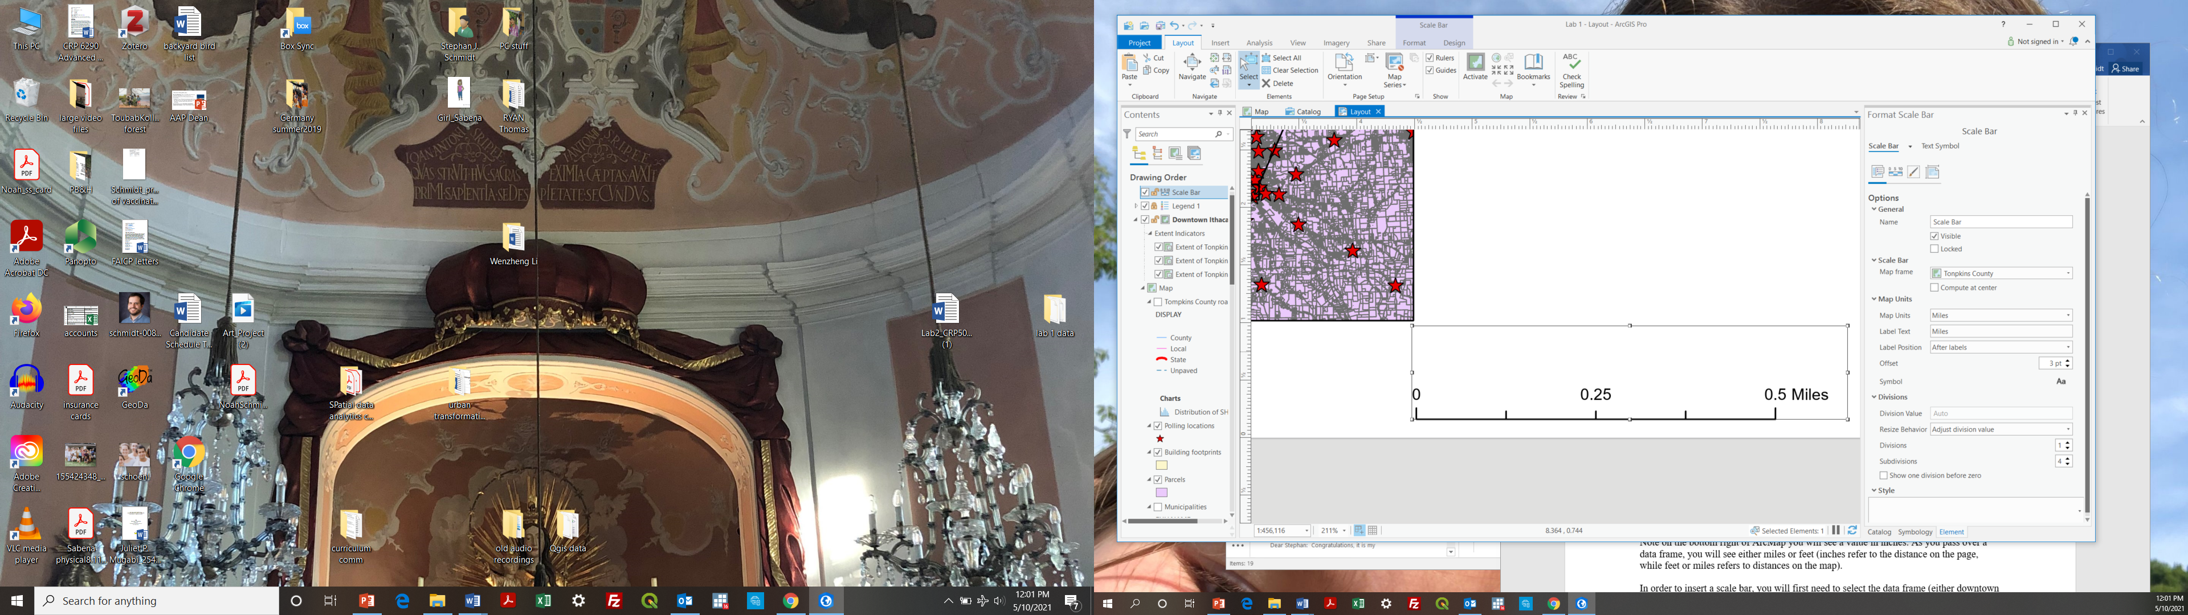

## *Insert text*

Next, you'll add a map title and some descriptive text. On the **Insert** tab, in the **Graphics and Text** group, click the **Rectangle text** tool . On the layout, above the map frame, draw a rectangle for your map title.

When you release the mouse button, the word **Text** appears inside an outline of the box. The text is highlighted so you can start to edit it.

On the ribbon, under **Text** tab, Adjust the font, style and size appropriately. Alternatively, double click the text you just created; the text properties panel appears. Click Text Symbol and edit the text format.

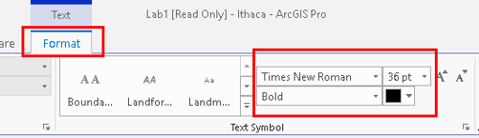

*Change Text Format under Ribbon*

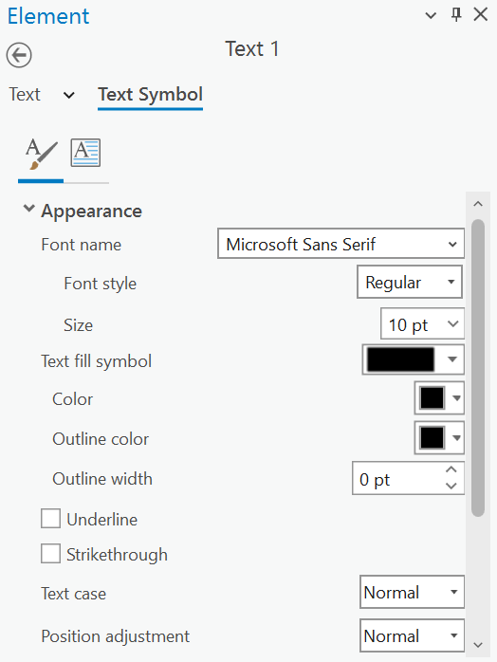

*Editing Text Format Under text symbol/properties*

Add an appropriate title (short, concise, direct) and sub-title (if necessary). When you're finished, click an empty area on the layout. The text element is now selected on the layout.

It also typical to include a text box with name, date, data source and projection information, as well as other pertinent information. For now, the name and date are fine.

***Insert a north arrow*** (personally I prefer one with clean, modern lines, but that’s just me!), size and place on layout accordingly.

## *Export the layout*

Now that your layout is finished, you can print it or export it to a file that can be easily shared. On the ribbon, click the **Share** tab. In the **Output** group, click **Export Layout** .

The **Export Layout** pane appears. On the **Properties** tab, change **File Type** to PNG, JPEG or TIFF necessary.

In the **Name** box type Lab 1 or something similar. Click **Browse**  and browse to the location where you want to save the file.

At the bottom of the pane, click **Export**.

When the export is completed, click **View exported file** at the bottom of the pane. The file opens in your default image viewing application. If you want to print the layout, on the **Share** tab, click **Print Layout** . You may need to change some printer settings, such as the page orientation, before you send the layout to the printer.

**LAB 1 DELIVERABLES**

**Deliverables** *(should be submitted as a single word document saved as* ***last name_lab 1*** *to the Assignments link on Canvas. From now on,* ***all labs*** *should be submitted in a similar fashion). 40 points total.*

**MAP 1:** *A cleaned up, well organized map depicting parcels classified according to property class, polling places and streets for downtown Ithaca, plus a context map depicting municipalities for Tompkins County (i.e., the map we just produced). Be sure to include*

* + *north arrow,*
  + *scale bar,*
  + *title, and*
  + *text box with name, date, and data sources.*

*NOTE: You do not need to include the projection on this map since we have not discussed them yet.*

10 points

**Rubric**

One point each for:

1. Clear Title on -what, -where (and -when if appropriate)
2. Name and date,
3. Legend must have correct elements and be well-designed (no default layer names etc.)
4. north arrow and scale bar,
5. (2 pts) correct zoom on downtown Ithaca (approximate) and correct zoom on context map,
6. extent indicator and leader,
7. overall formatting is clear and clean
8. (2 pts) All layers are styled appropriately (roads, polling places, land uses)

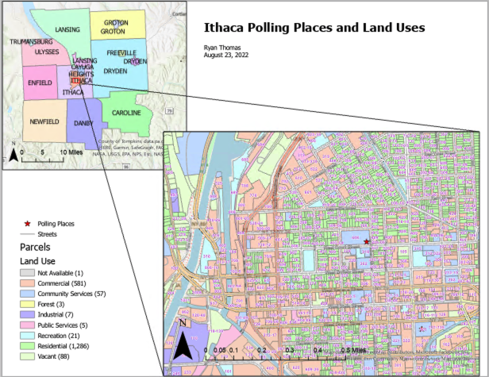

(This map is missing the data source: Barclay Lab; Tompkins County is merely the context, so no need to create a scale bar)

**MAP 2:** *Create a unique value map of all parcels in Tompkins County categorized by School District. Include roads and change the symbology so the state routes (NYS DOT) stand out (as we are including all of Tompkins County, no need for a context map).* 10 points

HINT: Examine this screen shots: Format parcel fill and outline the same.

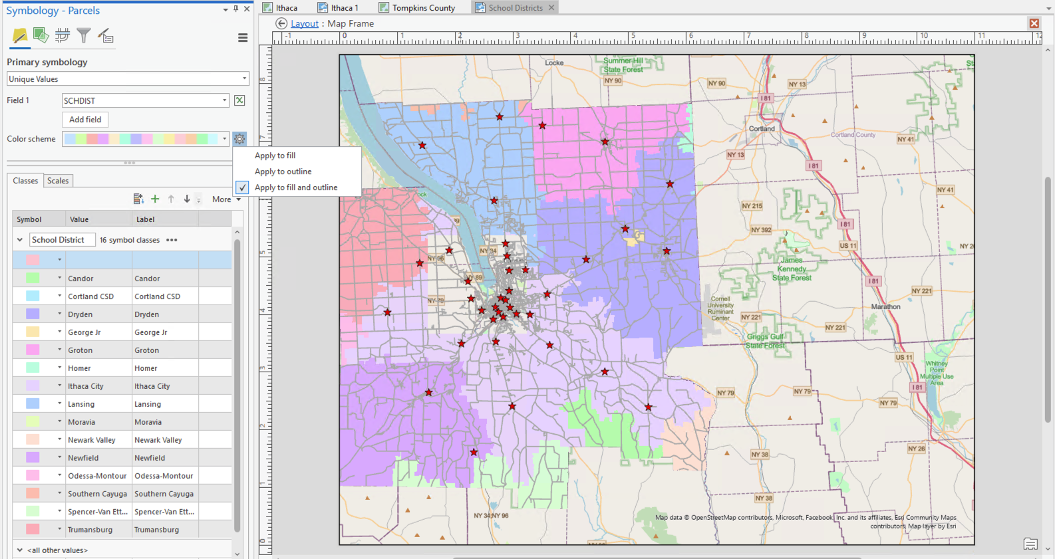

First, format all roads the same.

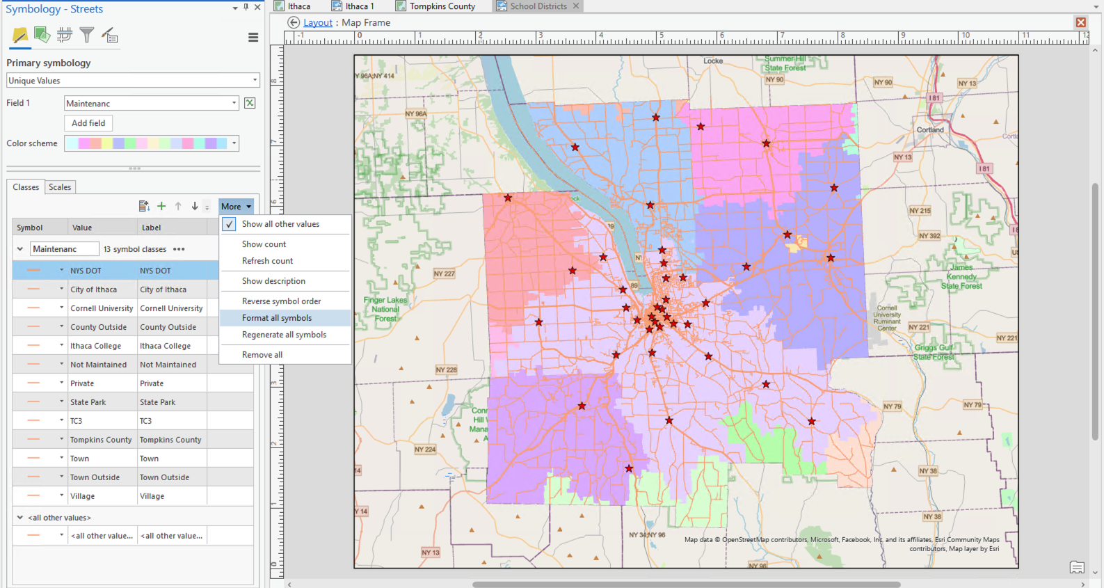

Then change the formatting for NYS DOT roads.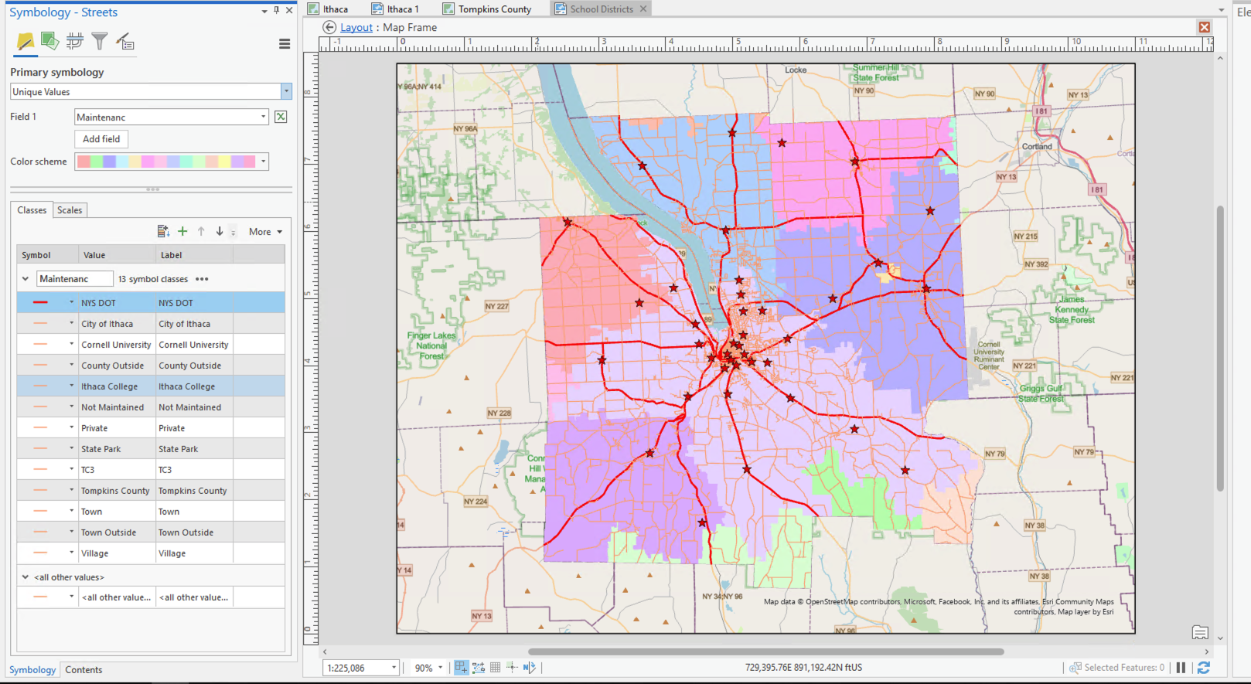

MAKE SURE TO CLEAN THE LEGEND!

**MAP 3:** *Create a unique values map of downtown Ithaca buildings categorized by building type.* *Change the symbology to highlight buildings categorized as commercial and retail (this time include Tompkins County context map).* 10 points

**Rubric**

One point each for:

1. Clear Title on -what, -where (and -when if appropriate)
2. Name and date,
3. Legend must have correct elements and be well-designed (no default layer names, only show categories reflected on the map, etc.)
4. north arrow and scale bar,
5. (2 pts) correct zoom on downtown Ithaca (approximate) and correct zoom on context map,
6. extent indicator and leader,
7. overall formatting is clear and clean,
8. (2 pts) All layers are styled appropriately (buildings by type, highlighting commercial and retail)

**MAP 4.** *A map of polling places labeled with addresses zoomed to the City of Ithaca. Include roads and context map.* 10 points

**Rubric**

One point each for:

1. Clear Title on -what, -where (and -when if appropriate)
2. Name and date,
3. Legend must have correct elements and be well-designed (no default layer names, only show categories reflected on the map, etc.)
4. north arrow and scale bar,
5. (2 pts) correct zoom on downtown Ithaca (approximate) and correct zoom on context map,
6. extent indicator and leader,
7. overall formatting is clear and clean,
8. (2 pts) All layers are styled appropriately (polling place labels are legible and appropriate size, road layer included)